Instructions Menu

The food will come down from the top to show the players where the food will come from and how fast it comes down.

Animated hand fades in as the food gets to the box. Presses down on the tap box to show what the player needs to do.

The bento box or tray will be shown at filling up as the food is tapped to show the players progress.

Play button should be accessible from the instructions screen. This way, younger players won’t become annoyed with having to navigate many different screens.

Tap accuracy will show “perfect” to show players how to get the highest score right at the start.

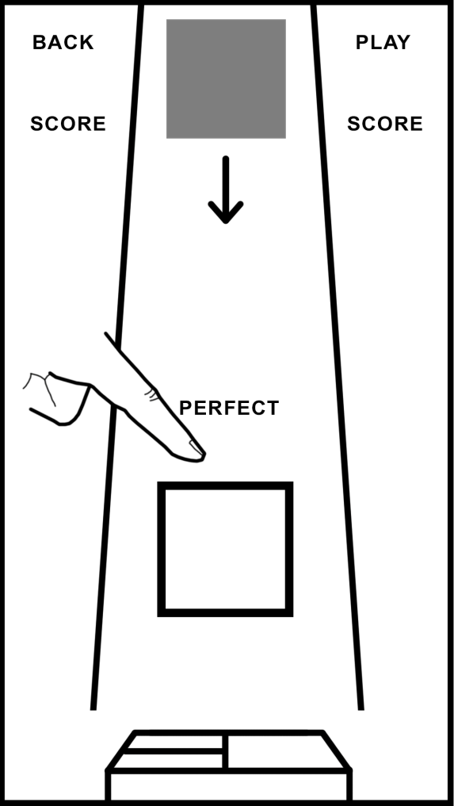

Sources:

<https://www.youtube.com/watch?v=NdFw8kvHAY8>

<http://uxkids.com/blog/position-of-navigation-buttons-affects-the-usability/>

<https://www.quora.com/Whats-important-when-designing-a-touch-user-interface-for-kids-apps>